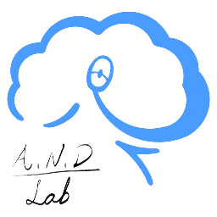
ANDlab Application form
Name : |  | Email :
Current status : | e.g., undergraduate, master's student, PhD | Applying for : | e.g., Post doc
Please answer the following briefly.
What are your research interests?

Do you have any neuroscience or other related research experience?

Do you have any coding or programming experience?

What are your plans for after graduation?

How did you hear about our lab, and what specifically drew you to apply?

Why should we consider you, specifically, for this position?

Do you have any constraints (e.g., course load, exams, other jobs) that may affect your availability?

